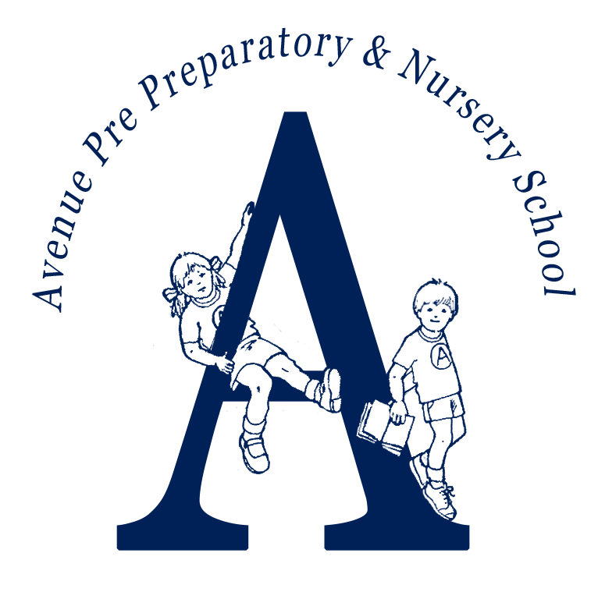
The Avenue Pre-Preparatory School and Nursery
APPLICATION FORM
The Avenue Nursery and Pre-Preparatory School is committed to Safeguarding and promoting the welfare of children and all applicants must be willing to undergo child protection screening appropriate to the post, during the course of the recruitment process, including checks with past employers, the Disclosure and Barring Service, the Barred List and Prohibited List and Social Media Screening. Some of the information we are requesting you to provide on this form is for this purpose.

Position applied for:
1. Personal details
Title: |  | Forename: |  |  | Surname:
Address: |  |  |  |  | Previous address: (If current is less than 5 years)
Mobile telephone: |  |  |  |  | Email:
Do you have right to work in UK? Please provide details. |  |  |  |  |  |  | Choose an item.
National Insurance Number:

2. Qualifications | YES | NO | Details / Reg Number
Do you have Qualified Teacher Status? | Choose an item.
Do you have an accredited NVQ Level 3 certificate, or above, in childcare? | Choose an item.
3. Academic Qualifications
Please provide details of all academic and vocational qualifications:
Dates | Award/Qualification | Awarding Body
Insert more rows if needed (using + button on the left side)

4. Professional Development
Courses (Attended during the last 3 years)
Dates | Name of Course (and award if gained) | Provider
Insert more rows if needed (using + button on the left side)

5. Career History
Please provide full details of all positions held in employment, self-employment and unpaid work since leaving secondary education.
Please start with your current or most recent employer and in each case the reason for leaving employment.
Dates | Employer/Training Establishment | Position held | Reason for leaving
Add more rows if needed
Please provide explanations for any periods not in employment, further education or training.
Dates |  | Reason
Add more rows if needed

Current Salary

6. Please set out in detail below a statement in support of your application, which addresses the criteria in the person specification for this post.
This box will expand as you type

7. Outside Interests
This box will expand as you type

8. Please confirm if you know any existing employee, volunteer or Governor at the School and if so, please provide full details of how you know them.

9. Referees
Please provide at least two professional referees. One referee should be your current or most recent employer.
Referee 1 |  | Referee 2
Name |  | Name
Address |  | Address
Position |  | Position
Tel No. |  | Tel No.
Email |  | Email
Confirm we can take up references

10. Data Protection
The information that you provide on this form will be used to process your application for employment. The personal information that you provide will be stored and used in a confidential manner to help with our recruitment process. More details as to how we will process your data is set out in the Recruitment Privacy Notice and Data Protection Policy.
If you succeed in your application and take up employment with the School, the information will be used in the administration of your employment.
We may check the information provided by you on this form with third parties.

11. Declaration
As the job for which you are applying involves substantial opportunity for access to children, it is important that you provide us with accurate answers. You should be aware that we will institute our own checks on successful applicants with the Disclosure and Barring Service (DBS), and, where appropriate, a check of the Barred List maintained by the DBS, and any offer of appointment will be made conditional on obtaining such satisfactory checks.
In line with KCSIE 2025 and safer recruitment practices, the school will conduct an online search for all shortlisted candidates. The online search is part of our safeguarding checks and will seek publicly available information on candidates’ suitability to work with children.
It is a criminal offence for any person who is disqualified from working with children to attempt to apply for a position within the School. We will report the matter to the Police and/or the DBS if:
- we receive an application from a disqualified person;
- we are provided with false information in, or in support of, an applicant's application; or
- we have serious concerns about an applicant's suitability to work with children.
I have not been disqualified from working with children, I am not prohibited from working with children, and I am not subject to any sanctions imposed by a regulatory body (e.g. the General Teaching Council for England, or the Teaching Regulation Agency).
I declare that the information I have given in this Application Form is accurate and true. I understand that providing misleading or false information will disqualify me from appointment or if appointed, may result in my dismissal.
Signature: Date:

Please return your completed application form to: Mrs Mary Fysh, office@avenuepreprep.co.uk
The Avenue Pre-Preparatory School and Nursery, 2 Highgate Avenue, London N6 5RX

